**OUTREACH SCHOOLS EXAMINATION BOARD**

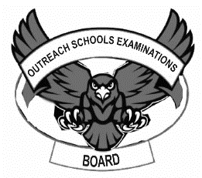 **END OF TERM II EXAMINATION 2024**

**BABY CLASS: (3 – 4 YEARS)**

**LEARNING AREA 2: LANGUAGE DEVELOPMENT 1**

**My name is: ………………………………..………………………….**

**My School is: ……………………………..……….…………………..**

**I am in: ………………………………..…………………………………………..**

1. **Read and draw.**

|  |  |  |
| --- | --- | --- |
| bag | ball | cup |
|  |  |  |
| box | cat | pot |
|  |  |  |

1. **Circle the different picture.**



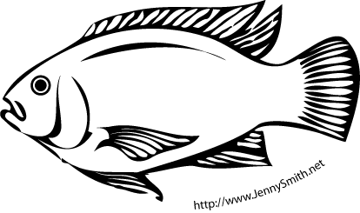

[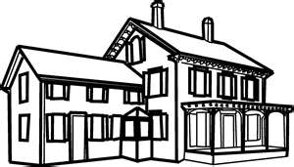](http://www.bing.com/images/search?q=a+pictures+for+children+showing+a+bungalow+house&view=detail&id=B94B767CA316A77BAA7BB9BA33BFEB66926043BC&first=241&FORM=IDFRIR)

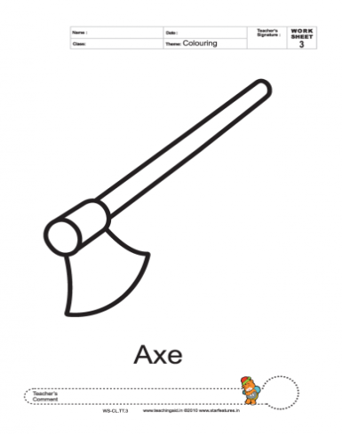

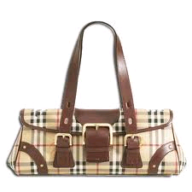

1. **Put the missing part.**

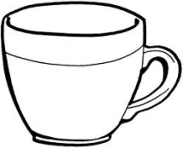

1. 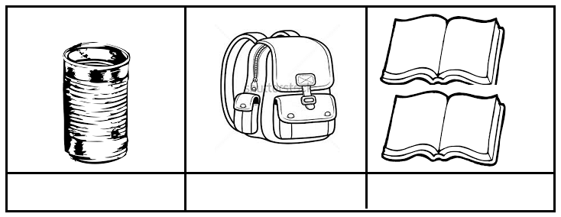**Read and match.**

cat

sun

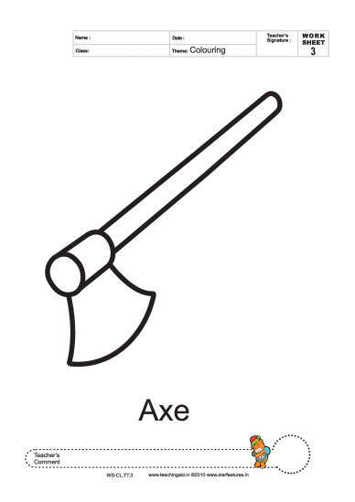

axe



pot

bag

**END**